14 August 2024

Subject Management’s Discussion and Analysis of the Financial Statement for the Second Quarter ended 30 June 2024

To Managing Director of The Stock Exchange of Thailand

Enclosure Management’s discussion and Analysis of the Financial Statement for the Second Quarter ended 30 June 2024

1 set each of Thai and English

Nova Organic Public Company Limited (“NV”) and its subsidiaries (“the Group”) would like to submit the Company’s audited Financial Statement for the Second Quarter ended 30 June 2024 to The Stock Exchange of Thailand.

The operation results of NV for the 6 months period ended 30 June 2024 registered a net loss amounting 39.3 Million Baht. Please see further details in the Management’s Discussion and Analysis of the Financial Statement as attached.

Please be informed accordingly.

Best regards,

(Ms. Yupin Chanjuthamard)

Chief Executive Officer

The Management’s discussion and Analysis of the Financial Statement for the Second Quarter ended 30 June 2024.

**Summary of operating performance**

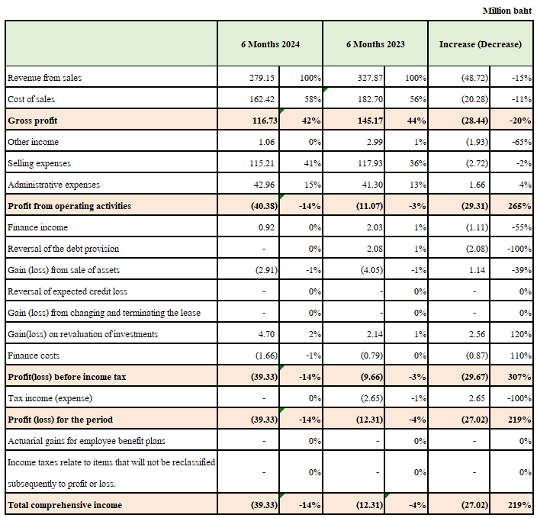

**operating performance**

The Group's total sales revenue for the 6 months period ended 30 June 2024 was 279.15 Million Baht, which decreased 15 percent from the same period last year. The main reason is coupled with the current economic recession. As a result of this, brings to the decreased of sale order quantity of this product.

**Gross Profit**

Gross Profit for the 6 months period ended 30 June 2024 was 116.73 million Bath, It was decreased 20 percent from the same period last year. Because the production cost of the marketed product group has a high cost. In addition, the company has organized a free product promotion in the sale of a set of products to stimulate consumer purchases. As a result, gross profit has decreased.

**Selling Expenses**

Selling expenses for the 6 months period ended 30 June 2024 were 115.21 million Baht. It was decreased 2.72 million Baht or 2 percent from the same period last year, mainly due to the company add the advertising and promotion expenses such as television program broadcast time rent, advertising production cost, actor salary and promotion cost. In line with the current market situation.

**Administrative Expenses**

Administrative expenses for the 6 months period ended 30 June 2024 were 42.96 million Baht. It was increase 1.66 million Baht or 4 percent due to increased administrative expenses.

**Net Profit**

The Company has net loss for the 6 months period ended 30 June 2024 was 39.3 million Baht, It was increased of 27.02 Million Baht or equals to 14 percent from the sale.

**Financial Position**

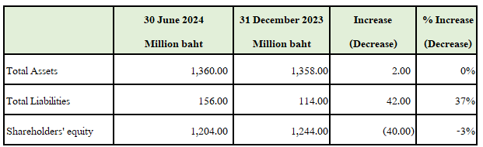

**Total Assets**

Total assets as of 30 June 2024 were 1,360 million Baht. It was increase 2 Million Baht from 31 December 2023 due to Investments in Associates.

**Total Liabilities**

Total liabilities as of 30 June 2024 were 156 Million Baht, It were increased 42 Million Baht from 31 December 2023 Mostly increase from financial institution loans.

**Shareholders' equity**

Shareholders' equity as of 30 June 2024 were 1,204 million Baht, It were decreased 40 Million Baht from 31 December 2023 by from the loss of the 6 months period of 2024 in the amount of 39.3 million baht.